Test Charter

**Charter** – Verify accept an offer functionality

**Areas** –

- Sign in

-Create a new request

-Submit the request

-Accept an offer

**Test Environment and URL** –

Test Environment and URL | <http://18.156.17.83:9095/>

Version EMUI 12.0.0, Browser - Google Chrome, Device - Huawei P20 Pro

Version Android 11.0, Browser –Mozilla Firefox, Device - One Plus 8, Tool | Lambda Test

**Start Date and Time** – 04.09.2022 | 15:00pm

**Tester** – Mateja Stojkovski

**Task Breakdown** –

* **Duration** – Short (30 min)
* **Test Design and Execution** – 15 min
* **Session Setup** – 10 min
* **Bug investigation and reporting** – 5 min

**Testing Notes** –

1. Sign in is successful
2. Navigated to the new URL: <http://18.156.17.83:9095/client/create-request>
3. Create request fill in all the fields
4. Click submit
5. Check request status is it active
6. Check if you have an offer
7. Accept the offer

**Bugs** –

* *Bug01* – Can't sent request from the phone

Expected result: Request should be sent

Actual result: Can’t submit my request

Tracking ID: 9923

* *Bug02* – Date can’t be clickable

Expected result: Should select date

Actual result: Can’t select date

Tracking ID: 9924

* *Bug0*3– Can’t change language

Tracking ID: 9925

* *Bug04* – Hamburger menu

Expected result: Menu should be remove after doing another function

Actual result: Menu doesn’t remove after doing another function

Tracking ID: 9926

**Data files –**

Bug01

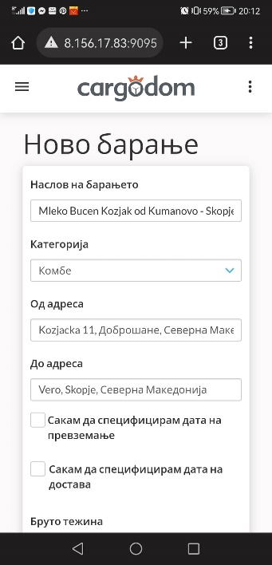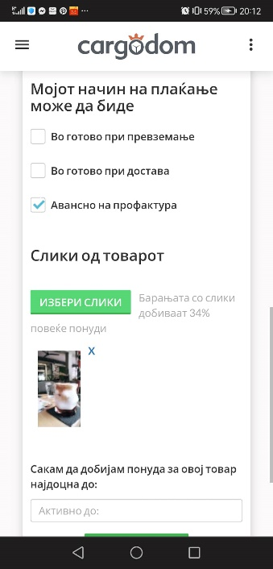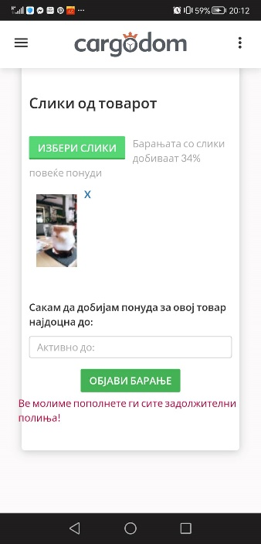

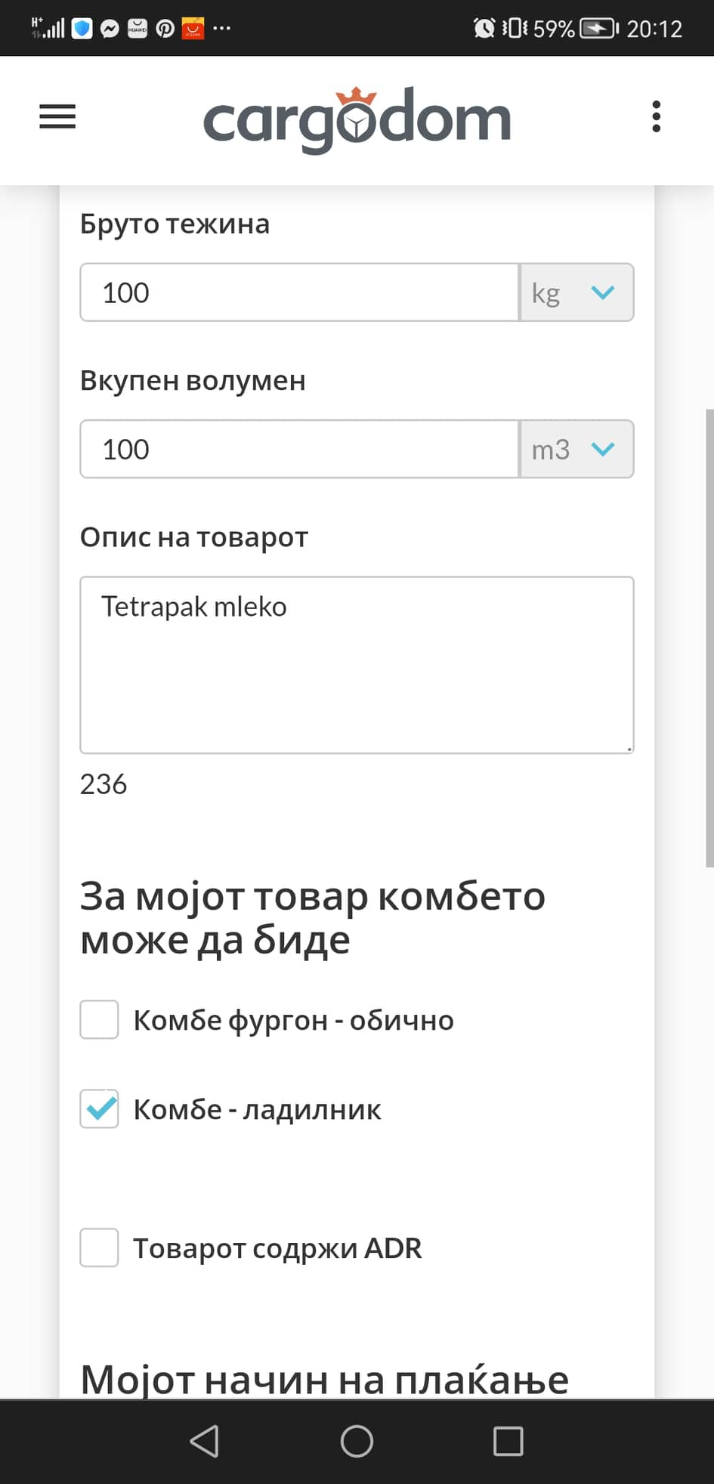

Bug 02 Bug 04 – One Plus 8



